Tiošpaye Wakaŋ
Holy Family



Wotapi Wakaŋ kiŋ
The Holy Eucharist or The Holy Feast
Season after Pentecost

The sacred space is marked by 6 flags with colors that correspond to the Four Directions and the Earth and Heavens. We ask that all who worship here (as much as possible) only move in a clockwise motion.

Tate Topa Olowaŋ
(Lakota Four Direction Prayer)
Wioĥpeyatakiya etuŋwaŋ yo Look to the West
Nituŋkaŝila ahituŋwaŋ yaŋkelo Your Grandfather is watching you
Cekiya yo, cekiya yo Pray! Pray!
Ahituŋwaŋ yaŋkelo He is watching you!

Waziyatakiya etuŋwaŋ yo Look to the North
Nituŋkaŝila ahituŋwaŋ yaŋkelo Your Grandfather is watching you
Cekiya yo, cekiya yo Pray! Pray!
Ahituŋwaŋ yaŋkelo He is watching you!

Wiohiyapatakiya etuŋwaŋ yo Look to the East
Nituŋkaŝila ahituŋwaŋ yaŋkelo Your Grandfather is watching you
Cekiya yo, cekiya yo Pray! Pray!
Ahituŋwaŋ yaŋkelo He is watching you!

Itoĝatakiya etuŋwaŋ yo Look to the South
Nituŋkaŝila ahituŋwaŋ yaŋkelo Your Grandfather is watching you
Cekiya yo, cekiya yo Pray! Pray!
Ahituŋwaŋ yaŋkelo He is watching you!

Wakaŋtaŋkakiya etuŋwaŋ yo Look to God
Wakantanka God
Heciya he yankelo He is sitting above watching us.
Cekiya yo, cekiya yo Pray! Pray!
Ahituŋwaŋ yaŋkelo He is watching you!

Makatakiya etuŋwaŋ yo Look to the Earth
Nikunsi k’un heciya he yankelo Your Grandmother is watching
Cekiya yo, cekiya yo Pray! Pray!
Anagopta yankelo She is listening to you.

Wotapi Wakaŋ Kiŋ The Sacred Feast or Holy Communion

The Service begins with Greetings and Announcements Standing, the Celebrant may say one of the following prayers

Lakota Collect for Purity
Wakaŋtaŋka iyotaŋ-waśaka, niye ekta wicacaŋte iyuha yugaŋ he ciŋhaŋ,
taku uŋciŋpi iyuha slolyaye, na niye etaŋhaŋ takuni anakiħme pica śni;
Nitaniya wakaŋ etaŋhaŋ wowiyukcaŋ uŋkitawapi uŋkiciyuśka piye,
hecel awicakehaŋ waśteuŋnilakapi kta, na Nicaje wakaŋ kiŋ yuonihaŋyaŋ
uŋyataŋkapi kta; Christ Itaŋcaŋ uŋkitawapi eciyataŋhaŋ. Amen.

English Collect for Purity
Almighty God, to you all hearts are open, all desires known, and from you no secrets are hid; Cleanse the thoughts of our hearts by the inspiration of your Holy Spirit, that we may perfectly love you, and worthily magnify your holy Name; through Christ our Lord. Amen.

A member of the congregation may cense the People in a clockwise manner, using Sage, Sweet Grass and/or Cedar as may be needed. This is a sign of purification and blessing and may replace the General Confession.
Aziliya or Lakota Censing

Member(s) of the congregation, using a drum, sing the Four Direction Song with the congregation facing the appropriate directions for each verse. If no singers are present, the prayer may be recited by a member of the congregation or the Celebrant.
Tate Topa Olowaŋ (the Four Direction Song/Prayer)

The Celebrant may read
The Collect of the Day
Celebrant: The Lord be with you.
People: And also with you.
Celebrant: Let us Pray.

The Lessons
After the reading the Reader says
The Word of the Lord.
People Thanks be to God.

The People Stand
The Gospel
A Deacon or Priest reads the Gospel, first saying
The Holy Gospel of our Lord Jesus Christ according to _______.
People: Glory to You, Lord Christ.

After the Gospel, the Reader says
The Gospel of the Lord.
People: Praise to You, Lord Christ

The Sermon

The Prayers of the People
After each petition, the prayer leader says: “Lord in you mercy”
The people respond: “Hear our Prayer.”

The Offertory

Hymn

Doxology (found on page 10)

Wopila Taŋka Kiŋ The Great Thanksgiving
The people remain standing. The Celebrant, whether bishop or priest,
faces them and sings or says

Tuŋkašila Wakaŋtaŋka (Grandfather God) is here.
People God’s Spirit never leaves us.
Celebrant Lift up your hearts.
People We lift them to God.
Celebrant Let us always offer our thanks.
People It is right to offer thanks and glory.

Then, facing the Holy Table, the Celebrant proceeds

It is right, it is good and it is joyful, to always offer our thanks to our Creator, Tuŋkašila, for his gifts in all of Creation.

Of God the Son
Through Jesus Christ our Ciye Wakaŋ; who on the first day of the
week overcame death and the grave, and by his glorious
resurrection opened to us the way of everlasting life.

Therefore we praise you, joining our voices with all the faithful spirits, sacred beings, and all our relatives on Earth and in Heaven, who offer this song of praise:

The Celebrant and the People say this Sanctus.
Wakan, wakan, wakan, Itancan Wakantanka, all in heaven and
earth give you glory.

Then the Celebrant continues
Tuŋkašila, you loved your creation so much that when it was time, you sent our Ciye/Tiblo, Jesus Christ, to complete our adoption with the rest of your creation, through His Baptism and ours. We now stand within your creation as your humble children. Help us to see you and all our relatives within this holy ceremony, so that we may serve the world through our prayers and actions.

In the beginning, we wandered in darkness until through your care and calling, we entered into the sunlight where we joined the rest of your creation. You provided for our needs, teaching us how to live by always seeking your voice. When it was time, you sent your Holy Spirit, Woniya Wakaŋ, to bless Ina Wakaŋ Mary with the birth of her Caśke (Eldest son), Jesus, so that we might never walk alone again. He taught us how to pray, how to heal and how to mature as His brothers and sisters.
When it was time, Jesus took bread; and when he had given thanks to you, he broke it, gave it to his family and said, “Take, eat: This is my Body, which is given for you. Do this with me and with all our relatives.

After supper he took the cup of wine; and when he had given thanks, he gave it to them and said, “Drink this, all of you: This is my Blood of the Huŋka Kagapi Wakaŋ (Holy Adoption), which is shed for you and for all our relatives for the forgiveness of sins. Whenever you drink it, do this with me and with all our relatives.”

Tuŋkašila invites us to pray,
Celebrant and People
We thank you,
We praise you,
We offer ourselves to you.

The Celebrant continues
We make our offering to you with a humble heart, giving you these gifts of bread and wine.

We ask you to send your Woniya Wakaŋ (Holy Spirit) to bless these offerings that they would be ceremonial food of the Body of Christ and his Blood of the Otakuye Kagapi Wakan (Holy Adoption). Help us to stand with your son, our Ciye/Tiblo, Jesus Christ, that we might be good children in your creation, being made holy by your Woniya Wakaŋ (Holy Spirit). When it is time, return to us so we might always stand with all of your relatives as a sacred People.

By Jesus, with Jesus and in Jesus, in the completion of Tuŋkašila’s creation, all glory and honor is yours now and forever. AMEN.

And now, as Savior has taught us to pray,
The Celebrant and the People may say
Ate uŋyaŋpi, maħpiya ekta naŋke ciŋ,
Nicaje wakaŋ-lapi nuŋwe.
Nito-kicoŋze u nuŋwe.
Maħpiya ekta nita-wa-ciŋ ecoŋpi kiŋ,
he iyecel maka akaŋl ecoŋpi nuŋwe.
Aŋpetu iyohi aġuyapi kiŋ, aŋpetu kiŋ le uŋqu piye.
Na tona eciŋśni-yaŋ ecauŋ-kiciŋpi
wicauŋ-kici-ca-juju-pi kiŋ,
he iyecel wauŋ-ħta-nipi kiŋ
uŋki-ci-ca-juju piye.
Na taku wawi-yu-taŋye ciŋ ekta uŋkayapi śni piye;
Tka taku śice etaŋhaŋ euŋ-klaku piye;
Woki-coŋze kiŋ, na wowa-śake kiŋ, na wowitaŋ kiŋ,
hena ohiŋ-niyaŋ na ohiŋ-niyaŋ nitawa heoŋ. (AMEN.)

Our Father, who art in heaven,
hallowed be thy Name,
thy kingdom come,
thy will be done,
on earth as it is in heaven. .
Give us this day our daily bread.
And forgive us our trespasses,
as we forgive those
who trespass against us.
And lead us not into temptation,
but deliver us from evil.
For thine is the kingdom,
and the power, and the glory,
for ever and ever. Amen.

The Breaking of the Bread
The Celebrant breaks the consecrated Bread. A period of silence is kept and the Celebrant says

Alleluia. Christ our sacred Older Brother is sacrificed for us;
Therefore let us keep the feast. Alleluia.

The Bread and the Cup are given to the communicants with these words
Christ Taŋcaŋ kiŋ, Aguyapi Wakaŋ kiŋ.
This is Christ’s Body, the Sacred Bread.
and
Christ We kiŋ, Mni Śa Wakaŋ kiŋ.
This is Christ’s Blood, the Sacred Wine.

After Communion, the Celebrant says
Let us pray.
Celebrant and People
Tunkasila Wakantanka,
you have accepted us as your children
as we have been adopted by our Elder Brother Jesus Christ.
You have fed us with the sacred food
in the Sacrament of Christ’s Body and Blood.
Send us into the world in peace,
Taking your Spirit with us,
so we might serve all we meet as holy relatives.
Make us strong and brave to love and serve you
with happiness and peace devoted to you through
Jesus Christ our Savior. Amen.

The Bishop when present, or the Priest, may bless the people with these words or others.
Wakaŋtaŋka Iyotaŋ-wašaka Toyawašte kiŋ, Ateyapi kiŋ, na Ciŋhiŋtku kiŋ, na Woniya Wakaŋ kiŋ, niyepi el, na niopeyapi ohiŋniyaŋ uŋ nuŋwe. Amen.

The Blessing of God almighty, the Father, the Son and the Holy Spirit, be with you and remain with you forever. Amen.

A closing hymn may be sung here.

The Deacon or Celebrant dismisses them with these words.
Christ Wowaĥwa yuha uŋyapi kte. (Go in the Peace of Christ)
Wakaŋtaŋka wopila unkiyuhapi kta. (Thanks be to God.)

Glossary
Caske- Eldest Son, used by parent
Ciye- Eldest Brother used by brother
Hunka Kagapi- Adoption
Ina Wakan- Sacred Mother or Mary
Itancan Leader or Lord.
Tiblo- Eldest Brother used by sister
Tunkasila- Grandfather used in this circumstance as God.
Wakan Mysterious, in this circumstance as Holy.
Wakantanka The totality of the Creator or God.
Woniya Wakan- Holy Spirit

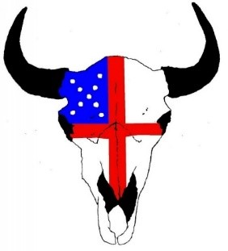

The Doxology

Ateyapi ciŋhiŋktu kiŋ,
Na woniya wakaŋ kiŋ he.
Wakaŋtaŋka waŋjila kiŋ
He wowitaŋ yuha nuŋwe.
Amen.

Itaŋcaŋ Tawocekiye kiŋ
(The Lord’s Prayer)

Ate uŋyaŋpi, maħpiya ekta naŋke ciŋ,
Nicaje wakaŋ-lapi nuŋwe.
Nito-kicoŋze u nuŋwe.
Maħpiya ekta nita-wa-ciŋ ecoŋpi kiŋ,
he iyecel maka akaŋl ecoŋpi nuŋwe.
Aŋpetu iyohi aġuyapi kiŋ, aŋpetu kiŋ le uŋqu piye.
Na tona eciŋśni-yaŋ ecauŋ-kiciŋpi
wicauŋ-kici-ca-juju-pi kiŋ,
he iyecel wauŋ-ħta-nipi kiŋ
uŋki-ci-ca-juju piye.
Na taku wawi-yu-taŋye ciŋ ekta uŋkayapi śni piye;
Tka taku śice etaŋhaŋ euŋ-klaku piye;
Woki-coŋze kiŋ, na wowa-śake kiŋ, na wowitaŋ kiŋ,
hena ohiŋ-niyaŋ na ohiŋ-niyaŋ nitawa heoŋ. (AMEN.)

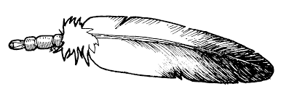

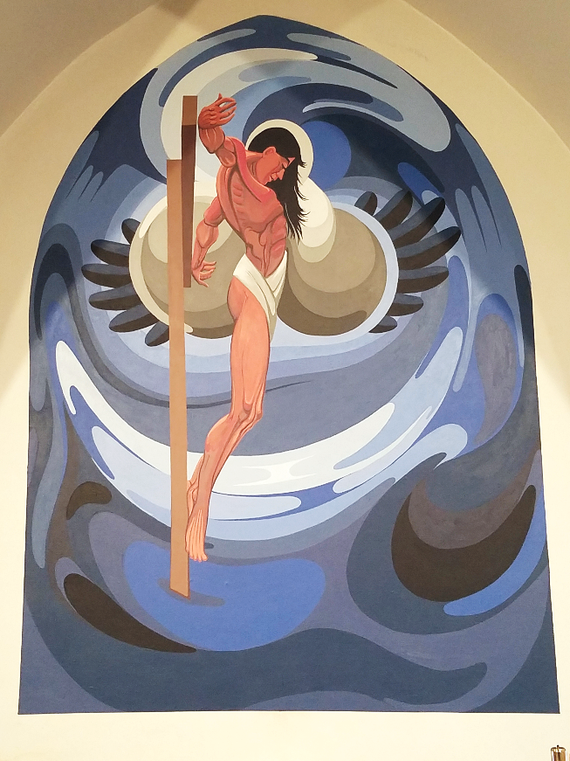
The Indian Christ by Oscar Howe
Located at St. Paul’s Episcopal Church, Vermillion, SD

Updated March 2026

